Polymorphism

By Tim Zufelt

CSE 210 – Programming w/Classes

Polymorphism is a cool word and it’s a cool way of saying that something can “change” or morph into something else. That is what we learned about today. Code in this weeks lesson took that exact process of changing on. We can create a parent class that holds information that a child class can references but with Polymorphism we can override that and put in new code thus changing the outcome. This really is just data taking on many forms and it occurs when we have many classes that are related to each through Inheritance.

Like last week, Inheritance lets us take on or “inherit” data from other classes. Polymorphism uses those methods to perform different tasks. This allows us to perform a single action in different ways.

Here is an example: we have our class Goal…

And referencing that class is Simple…

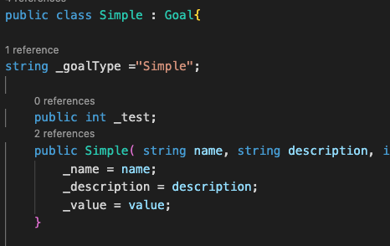

In the Simple class we reference the Goal class but can override the parent class with data from the child class.